14-Forest Products

This module processes the harvested carbon from grid cells into forest wood products that are used and disposed (Figure 14-1). In addition, some of the harvest can be processed for either internal or external bioenergy. This model is patterned after the FORPROD model (Harmon et al. 1996), although some pools have been combined and bioenergy has been added. This module operates on an annual time step. In addition to being able to process the harvested carbon directly, the amount of harvest carbon is also output as well in case the user wishes to process it using a stand-alone model.

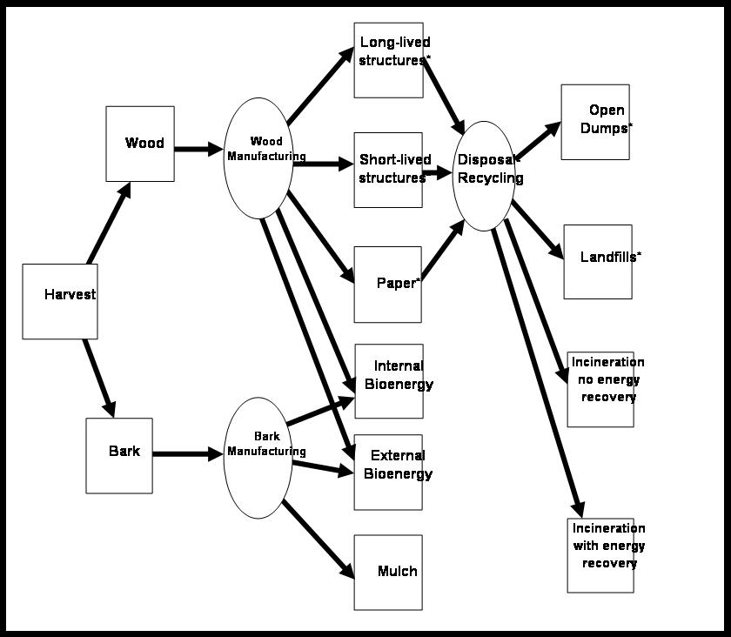

Figure 14-1. The forest products related pools and flows tracked by the LANDCARB model.

The files required to run this module include Manufacturing.prm which determines how the harvest is processed during the manufacturing step, ProductsUse.prm which determines how products are used and their life-span, and Disposal.prm which determines how products are disposed of once their life-span is exceeded. For each of these files there is a default set of parameters; however it is also possible to provide yearly changes in the parameters to reflect changes in manufacturing, use, and disposal practices. Each year need not be specified as the module will change the values when a new year is encountered.

When there is a harvest in a stand grid cell, a portion of the live wood (sapwood and heartwood) can be removed and processed into forest products. The harvest is first processed in the manufacturing step to produce inputs for the different product stores such as long-term structures, short-term structures, paper, and mulch. Bioenergy can be produced during manufacturing some of which is used by the forest sector (internal) and some of which is used outside the forest sector (external). Only the external bioenergy is counted as a potential fossil fuel offset. Once the new product inputs been accounted for product stores are then followed with losses due to fire and decomposition as well as those from disposal. As products are disposed, a proportion is recycled. This effectively reduces disposal rate. Disposed products can be sent to open dumps (high combustion and decomposition rates), landfills (no combustion and very low decomposition rates), incinerated with or without energy recovery. In the case of the former a potential fossil fuel offset is counted.

Bark-Wood Separation. The first step is to compute the amount wood versus bark in the harvested carbon:

HarvestWood=(WoodPercent/100)*Harvest

Where HarvestWood is the amount of harvested wood, WoodPercent is found in the Growth.prm file, and Harvest is the amount of carbon harvested in a grid cell. Bark mass is:

HarvestBark=Harvest-HarvestWood

Bark Allocation. Harvested bark can be allocated into mulch, internally used biofuels or externally used biofuels:

MulchBark=BarkToMulchFraction*HarvestBark

ExternalBiofuelBark= ExternalBiofuelFraction*HarvestBark

InternalBiofuelBark=HarvestBark- MulchBark- ExternalBiofuelBark

Wood Allocation. The next step is to allocate the wood into different manufacturing streams (structural, pulp, or bioenergy) which generically looks like this:

StreamProductsInput= StreamManEffic*StreamWood

Where StreamManEffic is the efficiency in creating the type of product and StreamWood is the amount of wood entering the given manufacturing stream (StructuralWood, PulpWood, ExternalBiofuel).

It is assumed that harvested materials used for bioenergy have fixed conversion rate to a carbon offset; this number is less than 1.0 (as biofuel contains less energy per unit carbon than fossil fuels) and is set lower when liquid bioenergy is created and higher when solid fuels are created.

Wood Manufacturing. The next step is to determine the fate of harvested carbon during manufacturing. Wood being processed for structural wood (i.e., lumber, plywood, and engineered materials) can end up as structural materials, chips for paper manufacturing, or internal biofuels (hogg fuel). For structural related products produced during manufacturing the generic equation is:

ProductWood= WoodToProductFraction*ManStructuralWood

Where ProductWood is the mass of structural, hogg fuel, or chips products, WoodToProductFraction is the fraction of wood converted to a given product, and ManStructuralWood is the mass of wood allocated to structural manufacturing.

The specific equations for each product are:

StructuralWood= WoodToStructureFraction*ManStructuralWood

HoggFuelWood= WoodToHoggFuelFraction*ManStructuralWood

ChipsWood= WoodToChipsFraction*ManStructuralWood

The next step in manufacturing is to produce paper stock is based on the amount of wood allocated to paper production and the amount of chips created from structural manufacturing. A fraction of chip-related carbon is lost during manufacturing used as an internal biofuel or decomposed on site in effluent treatment plants.

PaperStock=PaperManEffic*(ManPulpWood+ChipsWood)

Where PaperManEffic is the fraction of chips converted to paper stock. In addition, some internal bioenergy is created during paper manufacturing:

PulpBioEnergy= PulpBioFuelConversion*(ManPulpWood+ChipsWood)

Where PulpBioFuelConversion is the amount of wood chips and pulp converted to bioenergy that is used within the wood products sector.

Wood biofuels used external to the forest sector are computed as:

BiofuelExternalWood =ExternalBiofuelFraction*HarvestWood

Products Inputs. The next step is to compute the products in-use input flows:

LongTermStructureInput=Long-termStructureFraction* StructuralWood

Where LongTermStructureFraction is the fraction of structural wood manufacturing outputs allocated to long-lived structures.

ShortTermStructureInput= StructuralWood- LongTermStructureInput

PaperInput=PaperStock

MulchInput=MulchBark

BiofuelInternalInput= InternalBiofuelBark + PulpBioEnergy + HoggFuelWood

BiofuelExternalInput= BiofuelConvEffic*(ExternalBiofuelBark + BiofuelExternalWood)

Where BiofuelConvEffic is the efficiency of biofuels relative to fossil fuel energy (biofuels contain less energy per unit carbon than fossil fuels).

Product Losses In-Use. Once manufacturing steps are complete newly formed products are added to existing wood product stores including: mulch, long-term structures (average life-span > 30 years), short-term structures (average life-span < 30 years), paper, and external biofuels. While external biofuels are not a store per se, they are counted as one in the form of a fossil fuel offset. Each of these stores is potentially subject to losses via disposal and combustion/decomposition. In the case of mulch it is assumed that only decomposition losses occur. Internal biofuels have 100% loss each year. For external biofuels it is assumed that there are no losses ( although in theory if the fossils fuels they are offsetting are eventually used then there is some degree of “decomposition” of their value). For long-term structures, short-term structures, and paper there are losses from both disposal and combustion/decomposition.

Generically the mass of forest products each year is computed as:

ForestProductsNew=
ForestProductsOld-ΣAverageLossRate*ForestProductsOld+ForestProductsInput

Where ForestProductsOld is the value from the year before and LossRate is the proportion lost per year for the various loss paths (e.g., disposal or decomposition) and ForestProductsInput is the amount of a particular forest product being produced via manufacturing. If a harvest has never occurred in a stand grid cell, then the forest products store is set to zero.

Disposal Allocation. Once products are disposed of, they can have different final “fates” or disposal sites: open dumps (Dumps), landfills (LandFill), incineration without energy recovery (Incin) and incineration with energy recovery (IncinBioenergy). The general equation for all disposal streams is:

ProductToDisposalSite=DisposalSiteFraction* NetProductDisposalLoss

Where DisposalSiteFraction is the fraction allocated to the different disposal sites. For disposal losses there is a potential to reduce the flow to disposal sites by recycling. Effectively recycling reduces the disposal rate. However, recycling can not reduce the flow to disposal sites to zero because some recycled materials are not suitable for reuse. Therefore this fraction of loss is deducted from the planned recycling rate.

Disposal Site Losses. Disposal sites include open dumps, landfills, incineration without bioenergy recovery, and incineration with bioenergy recovery. Open dumps and landfills are both subject to decomposition/combustion losses. Open dumps differ from landfills in that they are subject to high losses from decomposition and combustion. Although decomposition in landfills is quite slow, some of this decomposition results in production of methane. However, this is not captured in the current module so that the carbon balance can be computed (as opposed to the greenhouse gas balance). Incineration without bioenergy recovery is assumed to release carbon within one year of disposal. Incineration with bioenergy recovery is assumed to have no losses, although as noted above there can be some loss in offset value if the fossil fuels are actually used.

The general equation describing these losses is:

DisposalSiteLoss=DisposalSiteLossRateConstant*DisposalSiteOld

Where DisposalSiteLossRateConstant is the fraction lost in a year and DisposalSiteOld is the store in the disposal site the previous year. For incineration without energy recovery the DisposalSiteLossRateConstant is set to 1.0, whereas for incineration with bioenergy recovery it is set to 0.

The mass of forest products in disposal each year is computed as:

DisposalSiteNew=
DisposalSiteOld- DisposalSiteLoss + ProductToDisposalSite

Where DisposalSite Old is the value from the year.

Average Loss Rate Calculations. In LANDCARB the rate of losses from decay and disposal can change over time. Since the manufacturing and use parameters can change over time and products produced from one period can exist with another, the loss rate parameters represent a weighted average of the previous and new parameter values. The AverageLossRate is therefore a weighted average of the previous value and the input value.

AverageLossRate=
(PreviousAverageLossRate*ForestProductOld +InitialLossRate*InitialForestProducts)/
(ForestProductsOld+ InitialForestProducts)

Where PreviousAverageLossRate and InitialLossRate represent the fraction lost in a year for the existing forest products and the new harvest, respectively. ForestProductOld and InitialForestProducts represent the forest products store the previous year and the input from the most recent harvest, respectively. The weighted average allows the rate of forest products loss to change over time.

